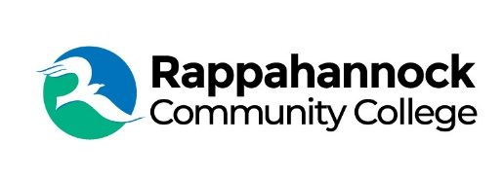

FOR IMMEDIATE RELEASE

Rappahannock Community College
Michele Inderrieden
Media Services Manager
minderrieden@rappahannock.edu
(804)333-6824
October 9, 2023

Rappahannock Community College Receives U.S. Department of Education Strengthening Institutions Grant

U.S. Senators Mark R. Warner and Tim Kaine, a member of the Senate Health, Education, Labor, and Pensions (HELP) Committee, on September 28, announced that Rappahannock Community College (RCC) will receive $422,892 in federal funding in FY2024 to improve the enrollment, retention, graduation rates, and professional outcomes for low-income students at institutions of higher education in Virginia. The award represents the first year of a multi-year grant that will provide RCC over $2.1 million over five years.

RCC is one of six community colleges in the Virginia Community College System awarded funding by the U.S. Department of Education’s Strengthening Institutions Program. The program was created to help colleges and universities become self-sufficient and expand their capacity to serve low-income students, by providing funds to improve and strengthen the academic quality, institutional management, and fiscal stability of eligible institutions.

RCC serves a 12-county region across the Northern Neck and Middle Peninsula of Virginia. The service area is the size of Delaware and is rural, interspersed with many rivers and creeks, covering 3,000 square miles. RCC’s region has a general population of approximately 192,000. The College has an annual head count of 3,259 and serves a diverse racial, cultural, and socio-economic student body.

“We are thrilled to receive this funding to help better serve our community,” said Dr. Shannon Kennedy, RCC President. “The funds will be used to improve and streamline student advising and career services, as well as increase the number of flexible, high-quality instructional opportunities to meet our students where they are.”

“Virginia’s colleges and universities play a key role in preparing Virginians for good-paying jobs,” said the senators in a press release. “We’re glad this federal funding will help these schools across Virginia better serve low-income and first generation students and make sure they have access to the resources they need to succeed.”

###

Since 1970, Rappahannock Community College has been breaking down barriers to education in the Middle Peninsula and Northern Neck. Five degrees, 6 certificates, and 26 career and workforce studies programs are offered through RCC, in addition to nearly 40 guaranteed admissions agreements with colleges and universities across the state and region. For more information, visit rappahannock.edu.

