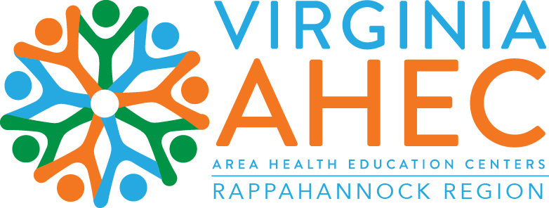

October 11, 2023

Rappahannock Area Health Education Center (AHEC) at Rappahannock Community College (RCC)
Stacie Wind
AHEC Director
(804) 333-6777
swind@rappahannock.edu

AHEC @ RCC Hosts RAM Free Clinic Serving the Rural Community

On a recent Friday in September, a tractor-trailer pulled up to Westmoreland High School. Volunteers began unloading medical equipment and supplies to fulfill a 48-hour mission to provide free medical, dental, and vision services to the uninsured and underinsured rural community. Remote Area Medical (RAM)—a major nonprofit of free pop-up clinics—coordinated with Rappahannock Area Health Education Center (AHEC), Rappahannock Community College (RCC), Westmoreland High School, and other community organizations to host the clinic.

Volunteers carted dental supplies, vision equipment, sheets and blankets, medical supplies, and countless other items into the school. In addition, they transformed the gymnasium into a 20-unit dental clinic, complete with space for an x-ray team. Hallways were filled with community resources and a book and food pantry, and classrooms became exam rooms, vaccine clinics, and even an area to order prescribed eyeglasses.

The pop-up clinics see patients on a first-come, first-served basis and allow registration to begin at midnight on Friday. The first patients are called in at 6 a.m. Saturday morning. RCC Chef Hatley Bright and her team of colleagues were on site all weekend to feed the volunteers and provide to-go lunches for the patients.

This year’s Montross RAM clinic was led by Stacie Wind, Director of the Rappahannock AHEC, located at RCC. “The Northern Neck and Middle Peninsula are significantly underserved, especially for access to vision and dental services,” said Wind. “Bringing RAM to the area provides the necessary services for uninsured or underinsured community members. Our hope is to connect them to resources and preventive ongoing care following the clinic.”

It takes a village to implement an event of this magnitude. Wind’s team worked tirelessly to seek businesses, nonprofits, churches, governmental organizations, and individuals who would donate funds, food, or time, and sometimes all three, in addition to creating awareness for potential patients and organizing everything from securing providers to managing the clinic layout.

Health profession students from RCC, William and Mary, University of Connecticut, University of Maryland, University of Virginia, Virginia Commonwealth University, Germanna Community College, Mary Washington University, and more contributed long hours to assist with all areas of the clinic. While some students operated in the logistical space, others were on the front lines of treatment, working triage, printing x-rays, checking blood pressures, temperatures, and blood glucose levels, administering vaccinations, and conducting medical history interviews before sending a patient to care. “It was a great way to give back to the community and apply our skills learned in the classroom,” said one nursing student. A RAM chapter from a college in Virginia volunteered the entire weekend with no preceptors present: “We love RAM clinics and volunteer whether we are limited to general support or have the opportunity to practice under a faculty member.”

By midday Sunday, when all those waiting had received treatment, 252 patients had received over $117,000 in free medical, dental, and vision services. More than 400 volunteers, some local, others traveling from out-of-state, helped make this RAM clinic successful.

“We’re pleased with the number of patients served and services rendered,” said Wind. “We held the clinic at a new location this year to allow for more dental stations and foresee a bigger and better clinic in the coming years.”

In addition to numerous donations by individuals, RCC would like to thank the following partners who helped make RAM free clinic successful:

Businesses:
Angelo’s Italian Restaurant
Anna’s Italian Restaurant
Bella’s Italian Restaurant
B. J.’s Wholesale Club
Buckler Bread Inc.
Central Rappahannock Region Library
Costello’s Ace Hardware Colonial Beach
Crazy Jack’s Sandwich Shack
Dameron Family Health & Wellness
E. A. Parker & Son’s LLC
El Torro Restaurant
Food Lion
Garner’s Produce
Hall’s Supermarket
Long Metalwork & Machine Inc.
Lynn Marine Construction, Inc.
PET Dairy (Robert Scott III)
Prince Street Café
River City Golf Carts
Schmidt Baking Co.
Seafood by Craig
Sysco
T. D. Self Farms
Ukrop’s Market
Virginia Department of Health
VCU Health Tappahannock
Wouroud Farm

Churches:
Bethany Baptist Church
Melrose Methodist Church
Milden Presbyterian Church
Rappahannock Church of Christ
The Gathering Church

Government:
Three Rivers Health District
Westmoreland Sheriff Department
Westmoreland Volunteer Fire Department
Richmond County

Media:
101.7 BayFM
104.9 WIGO
105.5 WRAR
HotMix VA
Northern Neck News
Northumberland Echo
Rappahannock Record
Rappahannock Times

Non-Profits:
Callao Moose Lodge
Callao Women of the Moose
Healthy Harvest Food Bank
Montross Moose Lodge
Richmond County Public Library
Tappahannock-Warsaw Moose Lodge
Virginia Cooperative Extension
Warsaw-Bauman Masonic Lodge
Westmoreland Masonic Lodge

Schools:
Germanna Community College
Mary Washington University
Rappahannock Community College
University of Connecticut
University of Maryland
University of Virginia
Virginia Commonwealth University
Westmoreland County Public Schools
William and Mary

About Remote Area Medical: RAM is a major nonprofit organization that operates pop-up clinics delivering free, quality dental, vision, and medical services to underserved and uninsured individuals who do not have access to or cannot afford a doctor. Since RAM was founded in 1985, more than 173,000 volunteers --comprised of licensed dental, vision, and medical professionals, as well as general support staff -- have treated more than 863,000 individuals, delivering $174 million worth of free healthcare services. For media inquiries about the upcoming clinic, please email communications@ramusa.org.

About RAHEC: Rappahannock Area Health Education Center’s mission is to recruit, train, and retain health professionals by connecting students to careers, professionals to communities, and communities to better care.

About RCC: Since 1970, Rappahannock Community College has been breaking down barriers to education in the Middle Peninsula and Northern Neck. RCC offers five degrees, six certificates, and 26 career and workforce studies programs, in addition to nearly 40 guaranteed admissions agreements with colleges and universities across the state and region. For more information, visit rappahannock.edu.

