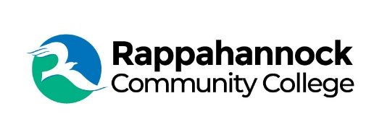
Rappahannock Community College
Michele Inderrieden
Media Services Manager
minderrieden@rappahannock.edu
(804)333-6824
January 31, 2024

Rappahannock Community College’s Economic Impact on the Region

A recent study prepared by Lightcast, a global leader in labor market analytics, indicates that Rappahannock Community College (RCC) added $99.2 million in income to its 12-county service region in fiscal year 2021-2022. The economic contributions came from operations spending, student spending, and alumni earnings and spending. The activities of RCC and its students support one out of every 56 jobs in the service region.

In fiscal year 2021-2022, RCC served 3,259 credit students, 771 non-credit students, and 274 employees. The average associate degree graduate from RCC will see an increase in earnings of $12,200 each year compared to someone with a high school diploma working in Virginia. The Lightcast study found that students receive a $7.50 return in higher future earnings for every dollar they invest in their education. Many area students would have left the service region if not for the existence of RCC. By staying in the area, student spending generated $688,800 in added income for the regional economy.

RCC’s short-term credential programs support regional workforce needs. Research by the Virginia Community College System reveals that students who complete FastForward short-term workforce training programs and go on to earn the resulting industry recognized credentials see average wage gains of $11,746 per year.

RCC has experienced a 4% increase in undergraduate enrollment from fall 2021 to fall 2023, and a 25% increase in credentialing and certification programs.

“The Lightcast Economic Impact Study report confirms that RCC and its students are a great investment,” said RCC President Dr. Shannon Kennedy. “We value the community’s support and commitment to our students and alumni.”

For every dollar of public money invested in RCC, taxpayers receive $2.30 in return over the course of students’ working lives. As RCC students earn more, they will contribute more to the tax base and purchase goods and services.

RCC influences the lives of its students as well as the regional economy by playing a key role in helping students increase their employability and retaining students in the region leading to new dollars and opportunities in the region. RCC supports 12-counties across the Northern Neck and Middle Peninsula, including Essex, Gloucester, King and Queen, King George, King William, Lancaster, New Kent, Mathews, Middlesex, Northumberland, Richmond, and Westmoreland.

The full report is available at www.rappahannock.edu/economicimpact.

###

Since 1970, Rappahannock Community College has been breaking down barriers to education in the Middle Peninsula and Northern Neck. Five degrees, 6 certificates, and 26 career and workforce studies programs are offered through RCC, in addition to nearly 40 guaranteed admissions agreements with colleges and universities across the state and region. For more information, visit rappahannock.edu.

