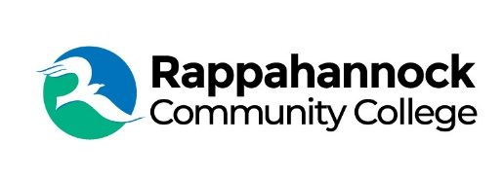

FOR IMMEDIATE RELEASE

Rappahannock Community College
Michele Inderrieden
Media Services Manager
minderrieden@rappahannock.edu
(804)333-6824
November 14, 2023

RCC to Host Rappahannock Tribe Assistant Chief Mark Fortune

In recognition of Native American Heritage Month, Rappahannock Community College, welcomes Rappahannock Tribe Assistant Chief Mark Fortune to speak on November 21 at 12:30 pm. The presentation will be held in the lecture halls at both the Glenns and Warsaw campus as well as on Zoom for those who can’t attend in person.

Fortune is the director of river programs and a Tribal citizen with the Rappahannock Tribe. He began serving as the assistant chief in 1994, was project manager of the construction of the Tribe’s three-building government complex, and is responsible for the Youth Leadership Council. Fortune is a member of the Tribe’s Maskapow Drum group and led the Pow Wow planning committee while training one of his sons to assume leadership in 2022. Chief Anne Richardson and Fortune developed the Return to the River Youth Education Program.

Fortune will talk about the Rappahannock Tribe, life in the Tribe, its programs, traditions, and community outreach initiatives.

To receive the Zoom link you must register at https://vccs.zoom.us/meeting/register/tZErcemtrzkrGNG0VQZKBCeQ7tBRKkntUs4R or email Tychier Nickens at tnickens@rappahannock.edu

###

Since 1970, Rappahannock Community College has been breaking down barriers to education in the Middle Peninsula and Northern Neck. Five degrees, 6 certificates, and 26 career and workforce studies programs are offered through RCC, in addition to nearly 40 guaranteed admissions agreements with colleges and universities across the state and region. For more information, visit rappahannock.edu.

