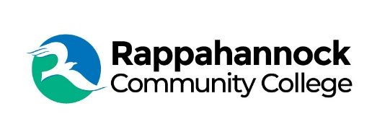

FOR IMMEDIATE RELEASE

Rappahannock Community College
Michele Inderrieden
Media Services Manager
minderrieden@rappahannock.edu
(804)333-6824
December 5, 2023

RCC Welding Program Expands in New Kent

Beginning January 6, 2024, Rappahannock Community College (RCC) will offer welding classes at the New Kent site located at 11825 New Kent Highway. The cafeteria area in the old New Kent High School has been transformed into a state-of-the-art instructional welding facility.

Students will learn SMAW (Shielded Metal Arc Welding) commonly called ARC welding, GMAW (Gas Metal Arc Welding) commonly called MIG, FCAW (Flux Cored Arc Welding) referred to as FLUX, GTAW (Gas Tungsten Arc Welding) or TIG, and ASME IX Pressure pipe welding. All classes will earn the student an American Welding Society (AWS) welding certification.

The demand for certified welders is growing especially with the “Navy’s aggressive timeline to build two Virginia-class boats annually, as well as manufacture six modular components for every Columbia-class submarine” at Newport News Shipbuilding, according to an article in the 2023 Hampton Road Business magazine. The AWS’ website https://weldingworkforcedata.com/ cites statistics from the Bureau of Labor projecting that between 2023 and 2027 an average of 90,000 welding jobs will be available. Job openings are the result of an aging workforce and industry growth.

“RCC has a successful welding program at the Glenns campus and at the Westmoreland Workforce Training Center in Montross,” said RCC President Shannon Kennedy. “Building a state-of-the-art training facility in New Kent, with the support of the AWS and New Kent County, was a logical next step to expand regionally.”

The facility will have all new Lincoln 300C multi-process welders, Lincoln Prism welding extractors, and Miller Dynasty 400 water cooled TIG machines. “I’m looking forward to training welding students at this awesome facility,” said Craig Donor, RCC Welding Program Head. “Welding is a valuable skill that can lead to a rewarding and lucrative career.”

Class sessions are scheduled from January through August. There are Monday through Thursday morning or evening classes lasting four weeks as well as Saturdays for nine weeks. A variety of tuition assistance and financial resources are available to help students afford the costs.

“Our instructors are focused on safety, quality, and the responsibilities associated with certification,” added Kennedy. “I’m proud of our program and excited to expand to New Kent.”

For more information on this program, contact RCC at (804)758-6730 or email advisor@rappahannock.edu.

###

Since 1970, Rappahannock Community College has been breaking down barriers to education in the Middle Peninsula and Northern Neck. Five degrees, 6 certificates, and 26 career and workforce studies programs are offered through RCC, in addition to nearly 40 guaranteed admissions agreements with colleges and universities across the state and region. For more information, visit rappahannock.edu.

