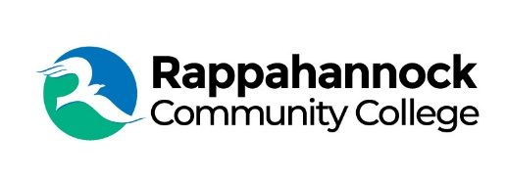

FOR IMMEDIATE RELEASE

Rappahannock Community College
Michele Inderrieden
Media Services Manager
minderrieden@rappahannock.edu
(804)333-6824
January 22, 2024

Golf Tournament to Raise Funds for RCC’s Student Emergency Assistance Fund

Rappahannock Community College dual-enrollment student Andrew White is organizing a golf tournament to benefit RCC’s Educational Foundation Inc.’s Student Emergency Assistance Fund. The tournament will be held Friday, March 22, at historic Kingsmill Plantation Golf Course in Williamsburg.

Registration begins at 8 am and shotgun start at 9. Entry fee includes the round of golf, cart, range balls, gift bag, lunch and banquet. Challenge your friends to compete on the beautiful, historic course designed by Arnold Palmer and Edward Seay. The course boasts historic landmarks, deep woods, ravines, water, and more. If you’re not a golfer but want to participate, join for lunch or become a sponsor.

White, a senior at Gloucester High School has successfully completed RCC college courses and earned credits while still in high school as a dual-enrolled student. He has achieved welding certifications from RCC and will attend the Newport News Apprentice School in the fall as an X42 pipefitter and member of the golf team. “My time as a student and volunteer for various opportunities at RCC has taught me how important a community college education is, and I want to help make sure other students are able to have the same experiences without worrying about finances,” said White when asked why he decided to put together the golf tournament.

RCC’s Student Emergency Assistance Fund helps students who otherwise might have to decide between gas for their car to get to class or the ability to purchase a textbook. Ruth Greene, a long time and much-loved RCC professor set up the fund upon the death of her mother in 2019. She asked for donations in her mother’s memory to be given to the fund to help RCC students with basic needs and emergency assistance. Ruth unexpectedly passed away in 2020 and family and friends showed their love for Ruth by donating to the fund. “Ruth saw first-hand the impact of emergency assistance to help a student attend and excel in their classes,” said Sarah Pope, Executive Director of RCC’s Educational Foundation Inc. “We are grateful to Andrew for donating all golf tournament proceeds to the Emergency Assistance Fund.”

Participants can register as a team, an individual, or sponsor. For more information about the tournament visit www.rappahannock.edu/2024golftournament.

###

Since 1970, Rappahannock Community College has been breaking down barriers to education in the Middle Peninsula and Northern Neck. Five degrees, 6 certificates, and 26 career and workforce studies programs are offered through RCC, in addition to nearly 40 guaranteed admissions agreements with colleges and universities across the state and region. For more information, visit rappahannock.edu.

