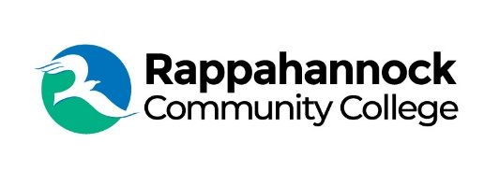
Rappahannock Community College
Michele Inderrieden
Media Services Manager
minderrieden@rappahannock.edu
(804)333-6824
January 10, 2024

From RCC to NN Shipbuilding, Alum Found His Calling

Fresh out of high school, Scott Pruitt, was unsure which career path to pursue but he knew he needed some form of professional training or higher education. A resident of Lancaster County, Pruitt enrolled in nearby Rappahannock Community College to try his hand at different subjects. “RCC is a fantastic and cost-effective way to expose yourself to higher education and see what appeals to you,” said Pruitt.

Pruitt enjoyed taking classes and learning new things. Two years after high school he earned an Associate of Arts and Sciences degree in Psychology. Following up on his first degree, he spent another two years earning an Associate of Applied Science (AAS) degree in Electrical Engineering. He was also a member of RCC’s Phi Theta Kappa (PTK) Honor Society. “The instructors at RCC are knowledgeable and passionate which enhances enthusiasm for the subject matter,” adds Pruitt. He found the coursework to be challenging with instructors willing to take time to help students work through problems, and share their wisdom.

His interest in electronics and engineering led Pruitt to pursue the Newport News Shipbuilding (NNS) Design Co-Op program through a partnership with RCC while taking the classes for the AAS degree in Electrical Engineering Technology. That portion of his college education was paid for by the NNS Co-Op program. This opportunity and experience provided him an entry-level designer position at the Shipyard once he completed the degree. He worked as a piping system designer in the CVN21 aircraft carrier program (CVN79 Gerald R. Ford) for about five years he decided to apply to The Apprentice School as a pipe fitter.

“I can say that the Apprentice School experience was transformative for me,” said Pruitt. “During my five years as a pipe fitter, I was able to work on the construction or overhaul of four submarines and seven aircraft carriers. The experience I gained and the connections I made along the way have been invaluable in my 15-year career at NNS.”

Pruitt’s advice to current and future students is to take time to get to know your instructors as people, especially those who have industry experience in a field in which you’re interested in pursuing. “If a college education is meant to propel you into a career, you should view your community college experience as the aiming portion of the launch,” he said.

NNS offers a wide range of career opportunities and as Pruitt attests, “You can do anything in the Shipyard.” Recently Pruitt was involved in the NNS Mobile Experience trailer showing high school students how ship building has evolved in using digital renderings and instructions and technology.

“The science and engineering faculty which I was fortunate to learn from all seemed to share a wonderfully dry sense of humor. Believe it or not, that probably helped as much as the coursework did in preparing me for a career in design and engineering,” said Pruitt. “Gain an understanding of the coursework but also of the actual work, and then you can confidently launch in the direction of your choice.”

###

Since 1970, Rappahannock Community College has been breaking down barriers to education in the Middle Peninsula and Northern Neck. Five degrees, 6 certificates, and 26 career and workforce studies programs are offered through RCC, in addition to nearly 40 guaranteed admissions agreements with colleges and universities across the state and region. For more information, visit rappahannock.edu.

