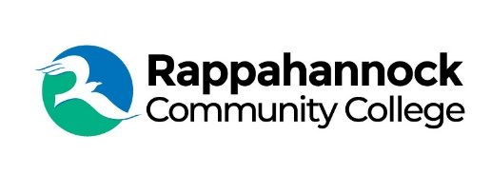

FOR IMMEDIATE RELEASE

Rappahannock Community College
Michele Inderrieden
Media Services Manager
minderrieden@rappahannock.edu
(804)333-6824
November 16, 2023

Regional EMS Symposium Held at Rappahannock Community College

Rappahannock Community College, Rappahannock Area Health Education Center, and Peninsulas EMS Council, Inc., hosted a Regional EMS Symposium November 10-12, 2023, at RCC’s Glenns Campus.

Over 50 Emergency Medical Services providers and community members, including Gloucester County’s Community Emergency Response Team (CERT) attended the Symposium. Attendees were able to participate in courses on a range of topics, including Mass Casualty Incident Management, Wilderness First Aid, Emergency Pediatric Care, Moulage Artistry, and more.

Additional presentations and training opportunities were conducted by various EMS providers, physicians, respiratory therapists, EMS educators, flight paramedics, lawyers, and the Regional Medical Director. Over 1,000 EMS continuing education hours were earned during the course of the weekend event.

The event was organized by Seth Craig, RCC’s EMS Program Head, with support from RCC President Dr. Shannon Kennedy, and many volunteers. Additional sponsors of the event included, Public Safety Group, Sovereign Medical, L3 Harris, and Atlantic Emergency Solutions.

###

Since 1970, Rappahannock Community College has been breaking down barriers to education in the Middle Peninsula and Northern Neck. Five degrees, 6 certificates, and 26 career and workforce studies programs are offered through RCC, in addition to nearly 40 guaranteed admissions agreements with colleges and universities across the state and region. For more information, visit rappahannock.edu.

