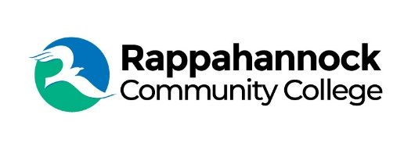

FOR IMMEDIATE RELEASE

Rappahannock Community College
Michele Inderrieden
Media Services Manager
minderrieden@rappahannock.edu
(804)333-6824
April 15, 2024

Celebrating the Value of Community Colleges

April marks the celebration of Community College Month, shining a spotlight on the important role played by institutions like Rappahannock Community College (RCC) in our communities and beyond. “Community College Month is an opportunity to celebrate the importance and value of our college to our community and to demonstrate how we are cultivating skills and preparing students for the future,” said Dr. Shannon Kennedy, RCC President.
Public community colleges like RCC offer affordable, accessible, quality higher education and skills training for all. RCC plays a fundamental role in training in healthcare, advanced manufacturing and skilled trades, culinary arts, transportation, engineering, public safety, business and more. In-person and online class options offer flexibility for adult learners juggling family and work responsibilities.
RCC's commitment to excellence is evident in the outstanding achievements of its students. The Practical Nursing program boasts a 100% pass rate on the NCLEX-PN exam, propelling graduates into fulfilling careers as Licensed Practical Nurses. Similarly, the fall 2023 cohort of Associate of Applied Science in Nursing achieved a perfect pass rate on the NCLEX-RN, affirming their readiness for the field.
The inaugural class in the Associate of Applied Science in Diagnostic Medical Sonography, Specialization in Echocardiography, achieved a 100% pass rate on the Sonography Principles and Instrumentation exam, demonstrating their preparedness to meet critical workforce demands.
Community College Month, spearheaded by the Association of Community College Trustees (ACCT), serves as a platform to promote awareness of the many benefits of attending public two-year colleges. By dispelling misconceptions and championing the economic, academic, and equity advantages they offer, the initiative seeks to empower individuals and communities alike.
“The nation’s community colleges always have specialized in providing practical education and skills that students can use to advance themselves in a competitive economy. They give opportunities to all students, and they support all students throughout their educations, whether they attend to attain an associate degree or certificate, intend to transfer on for a bachelor’s or higher degree, or they take one or a few courses to learn a new skill or expand their horizons,” said ACCT President and CEO Jee Hang Lee.
For over 50 years RCC has been a beacon of opportunity in the Middle Peninsula and Northern Neck regions, offering an array of programs and partnerships to foster educational and workforce advancement. With 12 degrees, six certificates, and 24 career and workforce studies programs, RCC continues to break down barriers to education and pave the way for a brighter future. For more information about RCC and its offerings, please visit rappahannock.edu.

