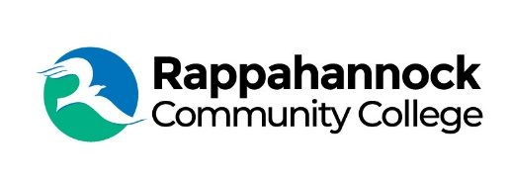

FOR IMMEDIATE RELEASE

Rappahannock Community College
Michele Inderrieden
Media Services Manager
minderrieden@rappahannock.edu
(804)333-6824
December 7, 2023
Rappahannock Community College Educational Foundation Announces New Board Member
Ellen Matthews Davis was appointed to the Rappahannock Community College Educational Foundation Board of Directors. She previously served on the Foundation Board in the early 2000s and also served on the College Board from 2015 to 2021. During the last three years of her tenure she served as board chair.
Davis was executive director of the Virginia Small Grains and Corn Growers Associations and an ex officio member of the Small Grains and Corn Checkoff Boards until 2006. She was then appointed State Director of Rural Development in 2006 by President George W. Bush and reappointed in 2009 by President Barack Obama. She retired from that position in January 2014. After retirement, Davis became the director of a regional research consortium working to leverage soybean checkoff funds, reduce redundancy, and prioritize local research in Maryland, Delaware, Pennsylvania, New Jersey, New York, and Virginia.
She and her husband, Ray, are partners in a 2,800-acre grain farm operation in New Kent County. “I am excited that Ellen is staying involved with the College. She is an excellent ambassador for RCC, a great leader, and a consummate professional,” said Shannon Kennedy, RCC President.
###

Since 1970, Rappahannock Community College has been breaking down barriers to education in the Middle Peninsula and Northern Neck. Five degrees, 6 certificates, and 26 career and workforce studies programs are offered through RCC, in addition to nearly 40 guaranteed admissions agreements with colleges and universities across the state and region. For more information, visit rappahannock.edu.

