|  |  |  |  |  |
| --- | --- | --- | --- | --- |
| **Begin Time** | **End Time** | **Session** | **Location** | **Presenter(s)** |
| 9:00 AM | 10:00 AM | Check in and continental breakfast | Student Lounge | Career Help and Mentoring for Parenting Students (CHAMPS), Office of Career & Transition Services |
| 10:00 AM | 10:45 AM | Books, Babies, and Barriers: The Reality of Parenting Students | Lecture Hall 122 (across from the Library) | Dr. Marlena Jarboe, RCC Vice President of Instruction and Student Success |
| **Breakout Session (Choose One)** | | | | |
| 10:45 AM | 11:15 AM | Discover Affordable Family Fun | Room 152, Computer Lab Classroom | Caitlyn Sydnor,  Student Activities Ambassador |
| 10:45 AM | 11:15 AM | Financial Literacy | Room 117, Workforce Area | Sherry Grantham, RCC Adult Education Regional Specialist |
| 10:45 AM | 11:15 AM | Healthy Living on a Budget | Room 170, Nursing Lab | Caroline White, CHAMPS Student Outreach Coordinator (Kilmarnock) |
| 10:45 AM | 11:15 AM | Virtual Reality Career Exploration | Room 118, Workforce Area | Giles Scott, Workforce Development Board |
| **Breakout Session (Choose One)** | | | | |
| 11:15 AM | 11:45 AM | Discover Affordable Family Fun | Room 152, Computer Lab Classroom | Caitlyn Sydnor,  Student Activities Ambassador |
| 11:15 AM | 11:45 AM | Financial Literacy | Room 117, Workforce Area | Sherry Grantham, RCC Adult Education Regional Specialist |
| 11:15 AM | 11:45 AM | Healthy Living on a Budget | Room 170, Nursing Lab | Caroline White, CHAMPS Student Outreach Coordinator (Kilmarnock) |
| 11:15 AM | 11:45 AM | Virtual Reality Career Exploration | Room 118, Workforce Area | Giles Scott, Workforce Development Board |
| **Lunch Reception, Student Lounge 12:00 PM to 12:45 PM** | | | | |
| 1:00 PM | 2:00 PM | Keynote Speakers and Parenting Students Panel | Lecture Hall 122 (across from the Library) | Dr. Marlena Jarboe  Darawn Kenner, Stacy Jessuph, Kwanita Yeo, Jamilia Franklin-Hafer, Latoya Bunns |
| 2:00 PM | 3:00 PM | Community resources and prize drawings | Student Lounge area | Various prizes & resources |

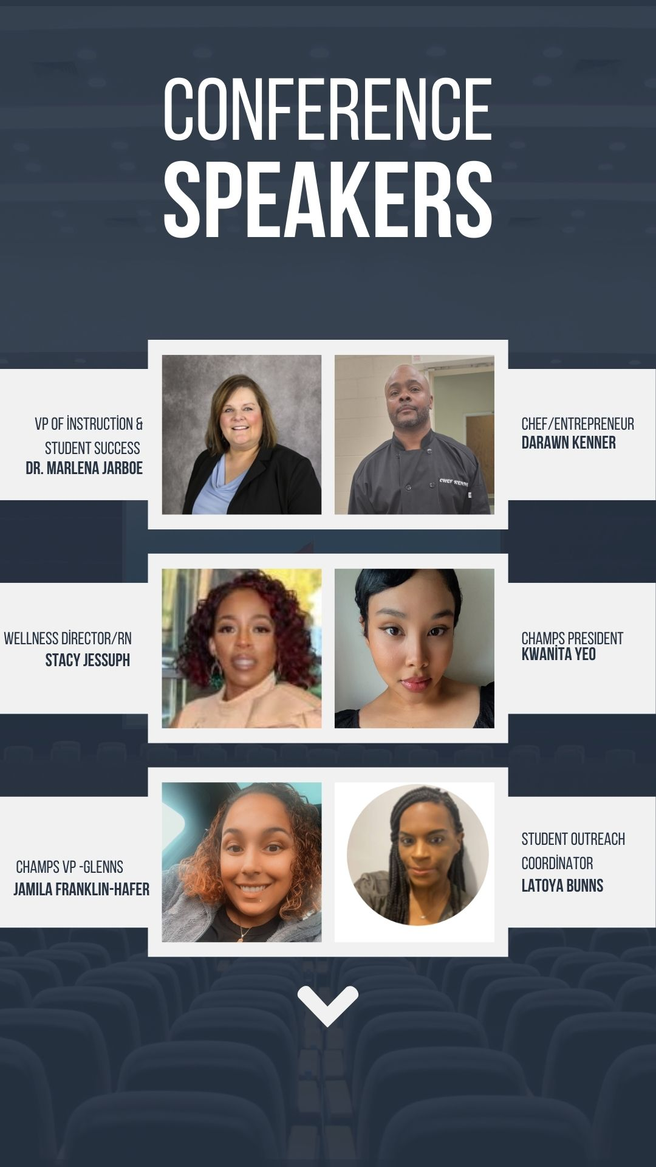



Special Thanks to Our Supporters & Speakers

Dr. Marlena Jarboe, Vice President of Instruction & Student Success RCC

Mr. Darawn Kenner, Activated Catering

Ms.Stacy Jessuph, RN

Ms. Kwanita Yeo, CHAMPS President

Ms. Jamila Franklin-Hafer, CHAMPS Vice President

Ms. Latoya Bunns, CHAMPS Student Outreach Coordinator

Rappahannock Community College Student Activities

Northern Neck Popcorn Bag (Terri Crowder)

Bunns & Bea Family Inspirational Self-Care Gift Basket

**If you are interested in joining CHAMPS,**

**please contact:**

Dr. Ebony Lynch, (804)333-6735 or by email: [elynch@rappahannock.edu](mailto:elynch@rappahannock.edu)

Ms. Theresa Sirles, (804)333-6889 or by email: [tsirles@rappahannock.edu](mailto:tsirles@rappahannock.edu)

